____/15 = ______% NAME: _____________________
Chapter 3 Assignment #5 – Energy Term 2 – C2 (4%)
- What is the main energy transformation that takes place in the following? (3)
  - A wood fire: ________________________ transforms into _____________________
  - A television: ________________________ transforms into _____________________

  - Hydroelectric dams: ___________________ transforms into _____________________
- A hydroelectric dam has an efficiency of 52%. How much kinetic energy from the water is needed to produce 900J of electrical energy? (2)

- Jan works out the efficiency of one of a windmill. The mechanical energy of the air hitting the blades of the windmills is 25 000 J each second. The energy transferred to the power lines is 5000 J each second. What is the energy efficiency of the windmills? (2)

- A hairdryer wastes 346J for every 1500J of electrical energy it uses. How efficient is the hairdryer? (2)

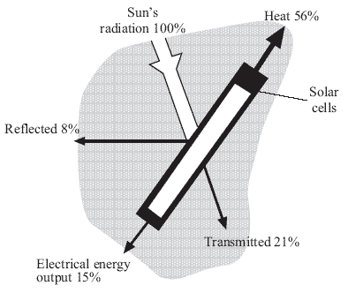
- What is the overall efficiency of the transfer of light energy from the Sun to electrical energy? (2)

- Each square metre of the solar panel receives 500 W. The area of the panel is 5m². How much energy falls on the panel in 2.5 hours? (Joules or kWh your choice) (2)

- Another panel of solar cells has an efficiency of only 8%. What is the electrical output of this panel when the input power is 2500 W? (2)

