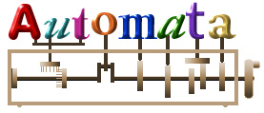Kinetic Art Project
You will be making an automaton.
Essentially you will be using a box (or another solid structure) to conceal a system of gears, pulleys & cams that, when turning, will allow art, placed on the outside of the box, to move.

The same concept is used in windup jewelry boxes, with a rotating figurine & children’s pull toys.
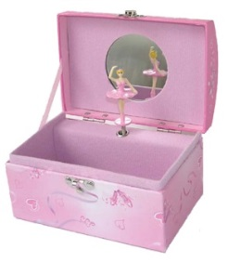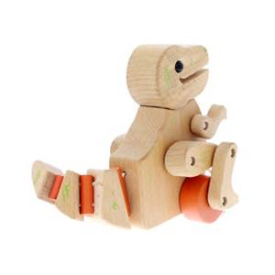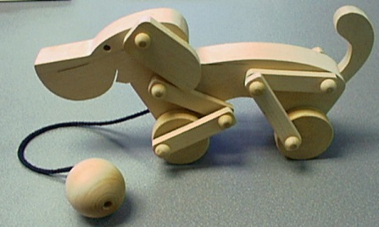
Materials:
- The school with provide the axels, gears, cams, skewers, paper, hot glue.
- Each team will receive 1 axel, 1 MDF cam of choice, 2 MDF wheels which students may glue at will!
- The school’s plastic cams and gears must remain reusable!
You may NOT hot glue or permanently attach these!

- Students are asked to supply: a box & any extra craft supplies. Cardboard can be used to make extra gears & cams if needed. Should a student like to use extra MDF wheels and plans to permanently glue them, they can be purchased from the teacher at cost for $0.50 each.

- Students may bring parts from toys, Lego, K’nex etc if they wish.

Important Dates:
Tuesday, March 15th , 2016 Project is introduced. Q & A. Brainstorm.
Thursday, March 17th, 2016 1st workday. Obtain supplies, brainstorm & start.
You have a weekend here! Look on-line for ideas, go to Dollarama for craft supplies!
Tuesday, March 22rd, 2016 Workday
Wednesday, March 23rd, 2016 Workday
Thursday, March 24th, 2016 Last Workday. Follow-up sheet will be handed out.
Take home if needed! EATER WEEKEND!
Wednesday, March 30th, 2016 Project due.

Evaluation:
The project will be evaluated according the rubric on the next page & the mark obtained from the follow-up sheet. It will count as 2 lab marks in term 3. (Competency 1)

Your automaton must have:
- 2 or more different types of systems (cam & follower, gears, belt & pulley, leaver, slider crank, etc.)
- Have a theme (a sport, animal duo, event, theme in pop culture, anything you can think of).

Evaluation Rubric:

Features | 2 | 4 | 6 | 8 | 10 | Mark
Effectiveness and Mechanical Design | Major problems  does not function | Functions irregularly or with low effectiveness | Functions satisfactorily  (needs minor adjustments) | Functions well  works, but jams or slips periodically | Excellent design and function  (reliable guiding & connections) | /10
Features | 1 incomplete system  Or  1 system & no art | 1 system & art  Or  Art is not involved with the movement of the system | 2 identical system with art  Or  2 different system & art has minimal effort | 2 different types of systems  &  art is well done | 3+ systems  (at least 2 are different) & art  Or  2 systems + extra element | /10
Overall Presentation & Effort | Lack of effort displayed | Minimal effort displayed *  No theme | Adequate effort displayed*  No common theme | Good effort displayed*  Theme present | Excellent work and effort displayed  Theme present | /10
Behaviour  &  Use of supplies | Names are clearly present on the FRONT of the project.  All plastic materials returned in good condition.  Group cleaned their table each day.  Group worked effectively each day.  Each member contributed to the project. (Individual deductions possible here), |  |  |  |  | /10
 |  |  |  |  | Follow-up sheet | /10
 |  |  |  |  | Final Mark | /50
- Effort is shown by:
  - Painting/decorating the box so that it no longer looks like a cereal box for example. Your project should have a finished look to it!
  - Having an evident theme. (you may give your automaton a title)
  - Your motion transmission or translation systems function well and have a guiding system so that it continues to function.

