Chemistry September 2017 Name: _____________________ Due:
WS1 Uncertainties Worksheet V1

1. Determine the measurements shown on each of the graduated cylinders shown below. Indicate the absolute uncertainty and units with each measurement.

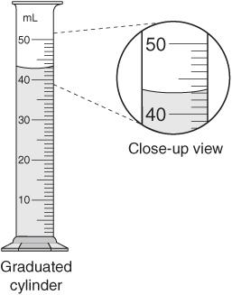

a)________________ b) ________________ c) ________________

2. Determine the length of each steel rod shown below. Indicate the absolute uncertainty and units with each measurement.

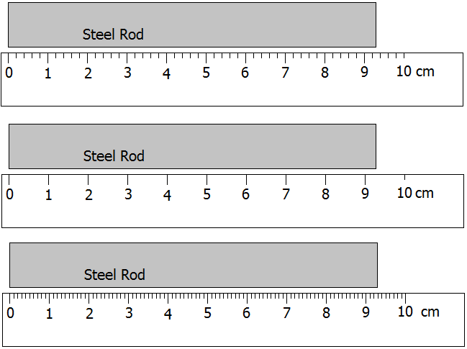

a)________________ b) ________________ c) ________________

3. An irregular object is placed into a graduated cylinder that contains (54.3±0.5)mL of water. The water level appears to rise to (86.6±0.5)mL. How much water does the object displace? Include units and uncertainties in you final answer. Show your work.

Final Answer: ______________

Chemistry September 2017 Name: _____________________ Due:
WS1 Uncertainties Worksheet V2

Determine the measurements shown on each of the graduated cylinders shown below. Indicate the absolute uncertainty and units with each measurement.

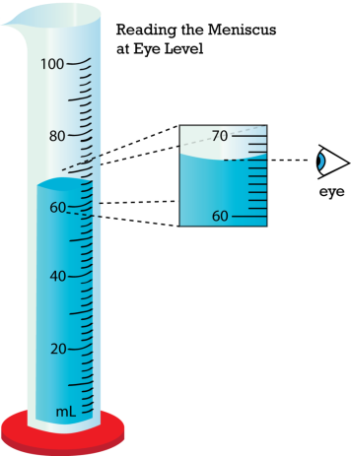

a)________________ b) ________________ c) ________________

Determine the length of each steel rod shown below. Indicate the absolute uncertainty and units with each measurement. (Rulers "a" and "c" are 12 cm long.)
b)

a)________________ b) ________________ c) ________________

3. An irregular object is placed into a graduated cylinder that contains (54.3±0.5)mL of water. The water level appears to rise to (86.6±0.5)mL. How much water does the object displace? Include units and uncertainties in you final answer. Show your work.

Final Answer: ______________

