Chemistry September Name: _____________________ Due:
WS1 Uncertainties Worksheet V4

1. Determine the measurements shown on each of the graduated cylinders shown below. Indicate the absolute uncertainty and units with each measurement.

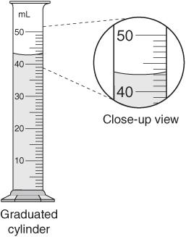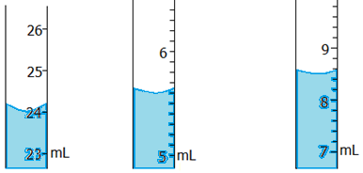

a)____________________ b) ______________________ c) _____________________

2. Determine the length of each steel rod shown below. Indicate the absolute uncertainty and units with each measurement.
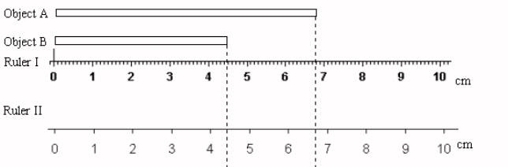

Ruler III

a)________________ b) ________________ c) ________________
Object A with ruler I Object B with ruler II Object C with ruler III

3. An irregular object is placed into a graduated cylinder that contains (54.3±0.5)mL of water. The water level appears to rise to (93.6±0.5)mL. How much water does the object displace? Include units and uncertainties in you final answer. Show your work.

Final Answer: ______________

