Worksheet on Pressure conversions, Manometers & Boyle's Law Name: ___________ __
Due next class
Calculate the following pressure conversions. (You do not need to show your work!) (4)

1. 111.8 kPa = ________ mm Hg 3. 780 mm Hg = _______ atm

2. 1.23 atm = ________ kPa 4. 685 mm Hg = _______ kPa

What is the pressure exerted by the gas sample for the following closed-end manometers. (You do not need to show your work!) (2)
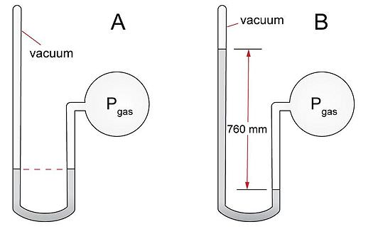
5. ____________ kPa

6. ____________ kPa

What is the pressure exerted by the gas sample for the following open-end manometers. (Show your work below)(4)
6. _____________ atm 7. ____________ atm

8. A gas occupies a volume of 78.4 L under a pressure of 1.08 atm and 15˚C. What volume will it occupy if the pressure is doubled without changing the temperature? (Show your work below)(2)

9. A gas that occupies a volume of 1.53 L exerts a pressure of 99.3 kPa . What pressure is required to compress the volume to 0.33 L? Assume that the temperature remains constant. (Show your work below)(2)

/12

